On BeDIS Smart Gateways and Zigbee Networks
Overview on functionalities, preliminary design and resources

Revision date | Contents | Contact
June 18, 2017 | - Overview  - Structure of smart gateway  - Preliminaries on setup and initialization and self test  - Links to resources: tutorials, specifications, sample code on  - MQTT, MQTT-SN,  - Related topics, e.g., REST architecture and APIs  - xxx | janeliu@iis.sinica.edu.tw

Overview
This note first presents a high-level description of smart gateways and zigbee networks of location beacons (Lbeacons) in BeDI (Building- environment Data and Information) mist. It then focuses on the Network Setup and Initialization (NSI) module in gateways. NSI should be among the first components to be designed and implemented.
Structure of BeDI mist
Fig. 1 shows the overall structure of a BeDI mist: Specifically, the figure depicts the structure of a gateway and its relationship with Lbeacons, BeDIS server and sources of emergency alert messages. The pdf file titled “BeDI enabled location specificity and IPS” contains a more detailed and complete description of the mist and its components. You can find the file at OpenISDM homepage under documents-> Publications-> Journal/conference papers.
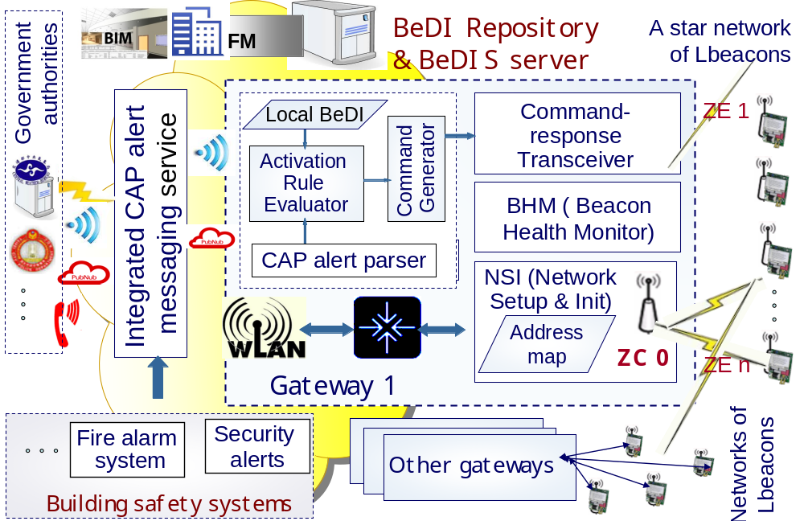
Fig. 1 Structure of smart gateway in a BeDI mist
In addition to the gateway component linking the local Zigbee network to the local area network of the building and from there to the BeDIS server, the large rectangle in upper right half part of Fig. 1 encloses the major components of a typical smart gateway. They are described below. In the description, the term local Lbeacons refer to the beacons connected by the Zigbee star network served by the gateway.
- iGaD (intelligent guard against disaster) shown in the upper left part of the box: It is composed of a CAP alert parser, an activation rule evaluator and a command generator. They are, respectively, for extracting from each CAP alert parameters specifying the type, severity, affected areas and time, etc. of the emergency/disaster warned by the alert; for choosing the action(s) to take in response to the alert based on the alert parameters and local building/environment data; and for generating the command(s) to be issued to Lbeacons based on the decision of the action rule evaluator: The inclusion of an iGaD enables the gateway to make location specific decisions on the action(s) to take by local Lbeacons in response to each CAP alert. A gateway may not contain an iGaD. In that case the command(s) to local beacons come from the BeDIS server.
- Command/response transceiver in the upper right corner: This component receives commands from either the iGaD in the gateway or the BeDIS server and broadcasts the commands to local LBeacons.
- Beacon Health Monitor (BHM): One of the requirements of an IPS for a large building is that the health of the system can be assessed during runtime on a regular basis. The health monitor and self test module in each gateway is for this purpose. Typically, the health of every Lbeacon is assessed once to few times a day:
  - Each time, the test is initiated by a request for health report (RFHR) command broadcast by the BeDIS server to the beacon health monitor (BHM) of every gateway.
  - Upon receiving the request, the BHM broadcasts its own request-for-health-report (RFHR) command to Lbeacons on the local star network.
  - Every beacon does a self test to assess its own health and report the result to the BHM. The paper mentioned above describes how this test is done currently and plans for more reliable tests. We can defer this work to later.
  - After receiving reports from all location beacons on the local star network, the BHM generates and sends to the BeDIS server a global health report, listing the ID and location of every defective or failed beacon thus identified. (The absence of a report from the Lbeacon within the timeout interval signals to the gateway that the beacon warrants attention.) The report is used as input on beacons needing repair by the facility management (FM) system of the building.
- Network setup and initialization (NSI) module shown in the lower right part of the big box in Fig. 1: As shown, NSI contains the coordinator node (ZC) of a Zigbee star network connecting all Lbeacons within a relative small area in the building. The module execute only during initialization and when individual beacons powers up.

NSI Operations
Without loss of generality, we assume that the initialization of BeDI mist has two phases. All components of smart gateways except NSI are initialized during phase 1. In particular, at the end of phase 1, the NSI has created an address mapping table, and the coordinator within NSI has been initialized and can start to process requests. The coordinator has the network address 0. The goal of phase 2 initialization is to set up the communication paths between Lbeacons, the gateway and the BeDIS server. This is done as follows:
- During initialization, each Lbeacon sends to a coordinator within its line of sight and range a join request containing its 3D coordinates. In response, the coordinator assigns a 16-bit network address to the beacon and sends the address to the beacon.
- The NSI module then creates an entry in the address table for the Lbeacon, associating its address with its coordinates. The module then gets from the BeDIS server the barcode and location description of the Lbeacon and maintain the information in the address map as the Lbeacon node joins the network. Lbeacons and gateways never sleep; so, this work is done only when the system powers up.
After initialization, the coordinator can address Lbeacons in the star network individually and identify the senders of packets from them. The former capability enables the gateway to support occasional transfers of data, including location specific commands and response instructions, to individual beacons. The latter enables the gateway to play a key role in health monitoring and self testing of the system.

Resources for Beginners
This section lists links to overviews, tutorials, etc. on related topics. They can provide a beginner with good places to start.
On ZigBee
- ZigBee/IEEE 802.15.4 Overview: Two sets of slides can give you a quick overview on Zigbee. One is at http://www.diit.unict.it/users/llobello/ss/IEEE802154.pdf, and the other one is used for a NCTU course at http://ocw.nctu.edu.tw/upload/classbfs1210030519111563.pdf
- “ZigBee/IEEE 802.15.4 Summary” by S. C.Ergen, http://home.iitj.ac.in/~ramana/zigbee.pdf This 2004 summary may be out of date at places, but is a better place to start then Wikipedia.

On MQTT-SN
MQTT-SN stands for MQ Telemetry Transport for Sensor Networks (a variation of the MQTT protocol) for embedded devices on non-TCP/IP networks. We will use it for Lbeacons and gateways. You can find discussions on MQTT versus MQTT-SN. Although we have no choice but to use MQTT-SN, it is good to hear such augments.
- The specification of MQTT-SN at http://mqtt.org/new/wp-content/uploads/2009/06/MQTT-SN_spec_v1.2.pdf
- Short and sweet answers to why use MQTT-SN, not MQTT at https://stackoverflow.com/questions/27560549/when-mqtt-sn-should-be-used-how-is-it-different-from-mqtt
- Pros and cons of MQTT versus MQTT-SN at https://www.quora.com/What-are-the-pros-and-cons-of-MQTT-versus-MQTT-S-as-network-protocols-in-IoT-Internet-of-Things
- MQTT-SN protocol client implementation: You can find sample code etc. at https://github.com/ibr-alg/wiselib/wiki/MQTTSN-client-implementation
- Tutorial: Prototyping a Sensor Node and IoT Gateway with Arduino and Raspberry Pi at https://thenewstack.io/tutorial-prototyping-a-sensor-node-and-iot-gateway-with-arduino-and-raspberry-pi-part-1/ -- Take a look at this tutorial first.
- Open source projects include
  - Eclipes Mosquitto project at https://eclipse.org/proposals/technology.mosquitto/
  - Eclipes Paho project providing client implementation of MQTT and MQTT-SN http://www.eclipse.org/paho/

On MQTT
- Introduction to MQTT – from the very, very beginning can be found at https://www.baldengineer.com/mqtt-introduction.html and https://www.baldengineer.com/mqtt-tutorial.html
- Step-by-step guides to MQTT https://www.survivingwithandroid.com/2016/10/mqtt-protocol-tutorial.html
- If you like to watch video go to https://www.youtube.com/watch?v=-KNPXPmx88E

Related topics
On REST and RESTFUL
- What is RESTFUL API (programming) https://stackoverflow.com/questions/671118/what-exactly-is-restful-programming
- REST, Roy Fielding’s Ph.D thesis, 2000 “Architectural Styles and Design of Network Based Software Architecture” at https://www.ics.uci.edu/~fielding/pubs/dissertation/top.htm

There are two types of devices in a Zigbee network: Full function devices and reduced function devices. A full function device can operate in all three modes: as an end device, a coordinator or a PAN (personal area network) coordinator. There is only one coordinator in each network. It is the device that started the network when the network powers up and stores information about the network including security keys. A reduced function device can only operate as an end device in a star network, as it can communicate only with the coordinator. In BeDIS, the NSI contains the coordinator of the local star network. All Lbeacons are reduced function devices. For more information, see the overviews and summary at the links listed in the sections on resources.

